- INTRODUCTION
1.1 PROBLEM SUMMRY
    - Problem Identification

A Human Resource Management System is a key tool for managing employee information, improving HR processes, and boosting productivity. However, many organizations face challenges that reduce the system's effectiveness, such as poor user experience, inaccurate data, integration problems, and compliance issues. Overcoming these challenges is important to make sure the HRMS meets the needs of the organization and delivers the desired results. This involves evaluating the system’s performance, gathering feedback from users, reviewing workflows, and performing security and compliance checks. By solving these problems, organizations can improve their HRMS, ensuring it helps achieve business goals and enhances overall HR management.
    - Problem Solution

A Human Resource Management System provides a comprehensive solution to the problems that modern businesses face in managing their human resources. An HRMS solves common problems including data silos, inefficiencies, and manual errors by centralizing employee data, automating administrative tasks, and streamlining HR processes. Intuitive user interfaces boost employee engagement, labor law compliance is ensured, and strong analytics are leveraged to enhance decision-making. An HRMS's integration features reduce duplication and increase accuracy by enabling seamless data transmission between payroll, attendance, and other systems. By implementing an HRMS, organizations may effectively manage HR concerns, boost productivity, and align human management with strategic objectives.

- PLANNING
2.1 MODEL DESCRIPTION
Feasibility study
Requirement analysis and specification
Design
Maintenance
Integration and system testing
Coding and unit testing
Fig 2.1 Iterative Waterfall Model
- In our project we are using iterative waterfall model.
- It is not possible to strictly follow the classical waterfall model.
- Making necessary changes to the classical waterfall model so that it becomes applicable to practical software development projects.
- The main change to the classical waterfall model is in the form of providing feedback paths from every phase to its preceding phases as shown in figure.
- The feedback paths allow for correction of the errors committed during a phase as and when these are detected in a later phase.
- For example, if during testing a design error is identified then the feedback path allows the design to be reworked and the changes to be reflected in the design document.
- There is no feedback path to the feasibility stage. This means that the feasibility study errors cannot be corrected.

Requirements analysis and specification
- The aim of the requirements analysis and specification phase is to understand the exact requirements of the customer and to document them properly. This phase consists of two distinct activities, namely
- Requirements gathering and analysis, and
- Requirements specification
- The goal of the requirements gathering activity is to collect all relevant information from the customer regarding the product to be developed. This is done to clearly understand the customer requirements so that incompleteness and inconsistencies are removed.
- The requirements analysis activity is begun by collecting all relevant data regarding the product to be developed from the users of the product and from the customer through interviews and discussions.
- During SRS activity, the user requirements are systematically organized into a Software Requirements Specification (SRS) document.
Design
- During the design phase the software architecture is derived from the SRS document. Two distinctly different approaches are available.
- Traditional design consists of two different activities; first a structured analysis of the requirements specification is carried out where the detailed structure of the problem is examined. During structured design, the results of structured analysis are transformed into the software design.
Coding and unit testing (Implementation)
- The purpose of the coding and unit testing phase of software development is to translate the software design into source code. Each component of the design is implemented as a program module. The end-product of this phase is a set of program modules that have been individually tested.
- Each module is unit tested for determine the correct working of all the individual modules.
Integration and system testing
- Integration of different modules is done once they have been coded and unit tested. During the integration and system testing phase, the modules are integrated in a planned manner.
- Finally, when all the modules have been successfully integrated and tested, system testing is carried out. The goal of system testing is to ensure that the developed system conforms to its requirements laid out in the SRS document. System testing usually consists of three different kinds of testing activities.
- α – testing: It is the system testing performed by the development team.
- β – Testing: It is the system testing performed by a friendly set of customers.
- Acceptance testing: It is the system testing performed by the customer himself after the product delivery to determine whether to accept or reject the delivered product.
Maintenance
- Maintenance involves performing any one or more of the following three kinds of activities:
- Correcting errors that were not discovered during the product development phase. This is called corrective maintenance.
- Improving the implementation of the system, and enhancing the functionalities of the system according to the customer’s requirements. This is called perfective maintenance.
- Porting the software to work in a new environment. For example, porting may be required to get the software to work on a new computer platform or with a new operating system. This is called adaptive maintenance.

2.2 Risk Management
- The aim of risk management is to reducing the impact of all kind of risks that might affect a project. Risk management consists of three essential activities: risk identification, risk assessment, and risk containment.
Risk Identification
- A software project can be affected by a large variety of risks. In order to be able to systematically identify the important risks which might affect a software project, it is necessary to categorize risks into different classes.
- The project manager can then examine which risks from each class are relevant to the project. There are three main categories of risks which can affect a software project:
Project Risks
- Project risks concern varies forms of budgetary, schedule, personnel, resource, and customer-related problems. An important project risk is schedule. It is very difficult to monitor and control a software project.
- It is very difficult to control something which cannot be seen.
- The invisibility of the product being developed is an important reason for many software projects failure.
- So in our project we are trying to resolve this kind of project risk which is also known as schedule risk.
Technical Risks
- Technical risks concern design, implementation, interfacing, testing, and maintenance problems.
- Technical risks also include ambiguous specification, incomplete specification, changing specification, technical uncertainty. Most technical risks occur due to the team member’s insufficient knowledge about the project.
- So in order to prevent this risk, we have done appropriate project analysis before starting our project.
Business Risks
- This type of risks include risks of building an excellent product that no one wants, losing budgetary or personnel commitments, etc.
Risk Assessment
- Risk assessment involves identifying risk, analyzing them and then assigns priority to them on the basis of the analysis.
- The objective of risk assessment is to rank the risks in terms of their damage. For risk assessment, first each risk should be rated in two ways:
- The probability of a risk coming true (denoted as r).
- The result of the problems associated with that risk (denoted as s).
- Based on these two factors, the priority of each risk can be computed:
p = r * s
- Where, p is the priority with which the risk must be handled, r is the probability of the risk becoming true, and so is the result of damage caused due to the risk becoming true. If all identified risks are prioritized, then the most likely and damaging risks can be handled first and reject procedures can be designed for these risks.
Risk Containment
- After all the identified risks of a project are assessed, plans must be made to containment the most damaging and the most likely risks.
- Different risks require different containment procedures. In fact, most risks require expertness on the part of the project manager in handling the risk.
- There are three main strategies to plan for risk containment:
- Avoid the risk: This may take several forms such as discussing with the customer to change the requirements to reduce the scope of the work.
- Transfer the risk: This strategy involves getting the risky component developed by a third party.
- Risk reduction: This involves planning ways to containment the damage due to a risk.
- To choose between the different strategies of handling a risk, the project manager must consider the cost of handling the risk and the corresponding reduction in risk.
- For this we may compute the risk leverage of the different risks. Risk leverage is the difference in risk divided by the cost of reducing the risk.
- Risk leverage = (Risk before reducing - Risk after reducing) / cost of reducing

- DETAIL DESCRIPTION

Admins
The "Admins" table manages administrator accounts for the bag store system. It stores login details and creation timestamps. This table ensures secure authentication and tracks when each admin account was created.
- id : Unique ID of Admin.
- username : Username of Admin.
- Password : Encrypted Password of Admin.
- created_at : Timestamp of account creation.

Admin_Login
The "Admin_Login" table stores authentication records for administrators. It contains login credentials that are required for admin access.
- userid : Unique ID for each admin login record.
- username : Unique username for login.
- password : Secure password for admin login.

Cart
The "Cart" table records items added to a shopping cart by users. It connects customers with the products they intend to purchase.
- cart_id : Unique identifier for cart item.
- user_id : ID of the customer who owns the cart.
- product_id : ID of the product added to cart.
- quantity : Quantity of product selected.

Category
The "Category" table manages product categories for the bag store. Each product belongs to a specific category.
- Cat_id : Unique identifier for each category.
- Cat_name : Name of the category.

Contact_Messages
The "Contact_Messages" table stores customer inquiries and feedback submitted through the contact form. It helps in communication management.
- id : Unique identifier for each message.
- first_name : First name of sender.
- last_name : Last name of sender.
- email : Email address of sender.
- message : Content of the message.
- status : Current status of the message.
- created_at : Timestamp when the message was created.

Order_Detail
The "Order_Detail" table stores details of customer orders including order amount and date. It helps track purchases made in the store.
- order_id : Unique identifier for each order.
- user_id : ID of customer placing the order.
- total_amount : Total value of the order.
- order_date : Date and time when the order was placed.

Products
The "Products" table contains details of items available in the bag store. Each product belongs to a category and may have an associated image.
- product_id : Unique identifier for each product.
- name : Name of the product.
- description : Description of the product.
- price : Price of the product.
- category_id : Category ID of product.
- image : Image path or filename of the product.

- DAIGRAMS
  - CLASS DIAGRAM

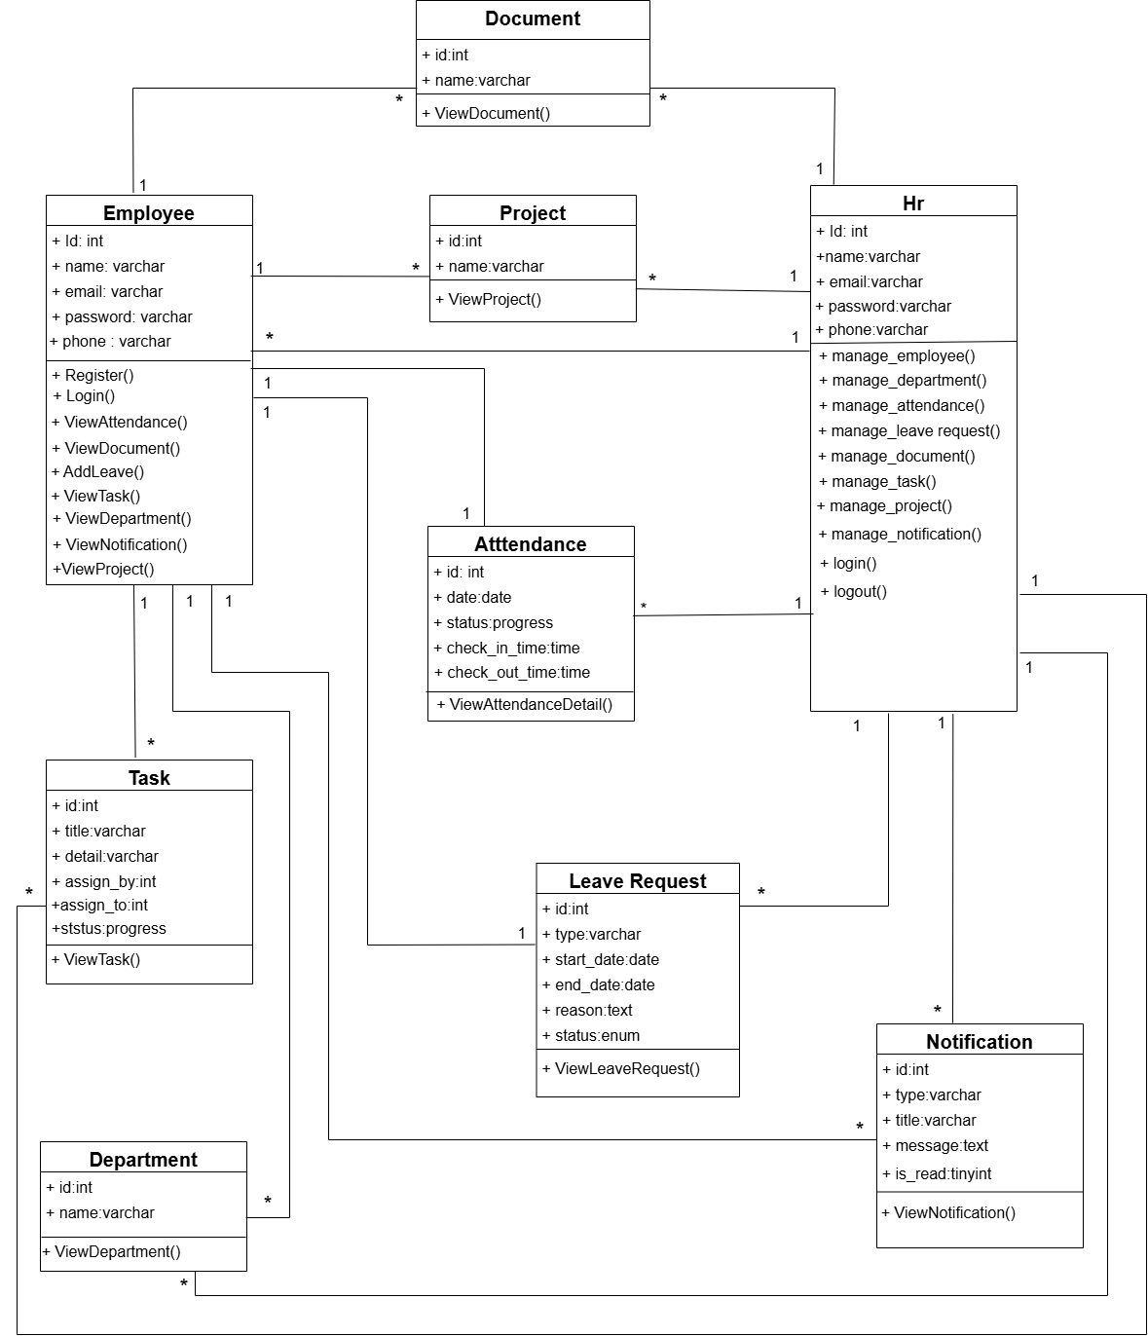
Fig 4.1 Class Diagram of Human Resource Management System

4.2 SEQUENCE DIAGRAM
4.2.1 SEQUENCE DIAGRAM FOR ADMIN

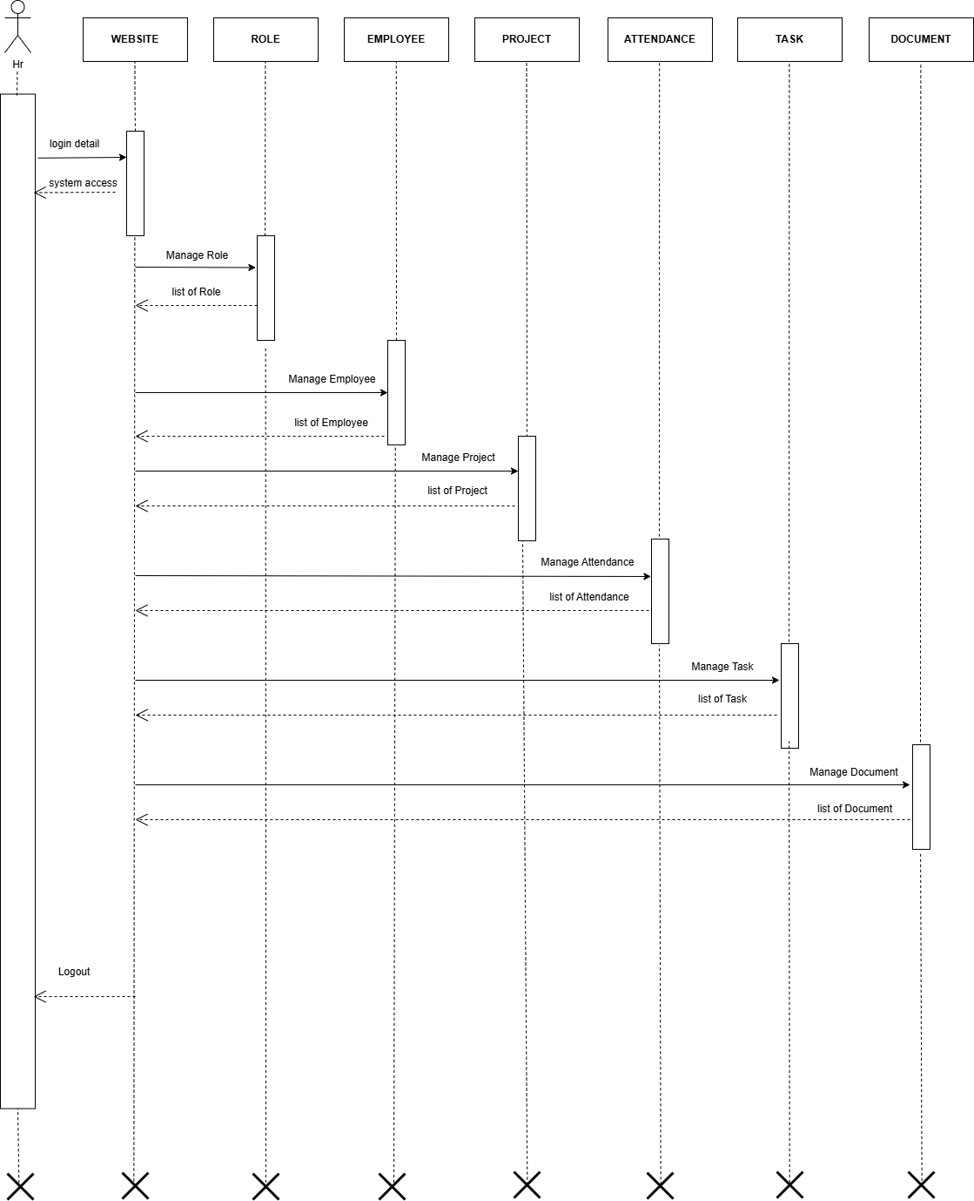

Fig 4.2.1 Sequence Diagram for Admin of Human Resource Management System
4.2.1 SEQUENCE DIAGRAM FOR USER

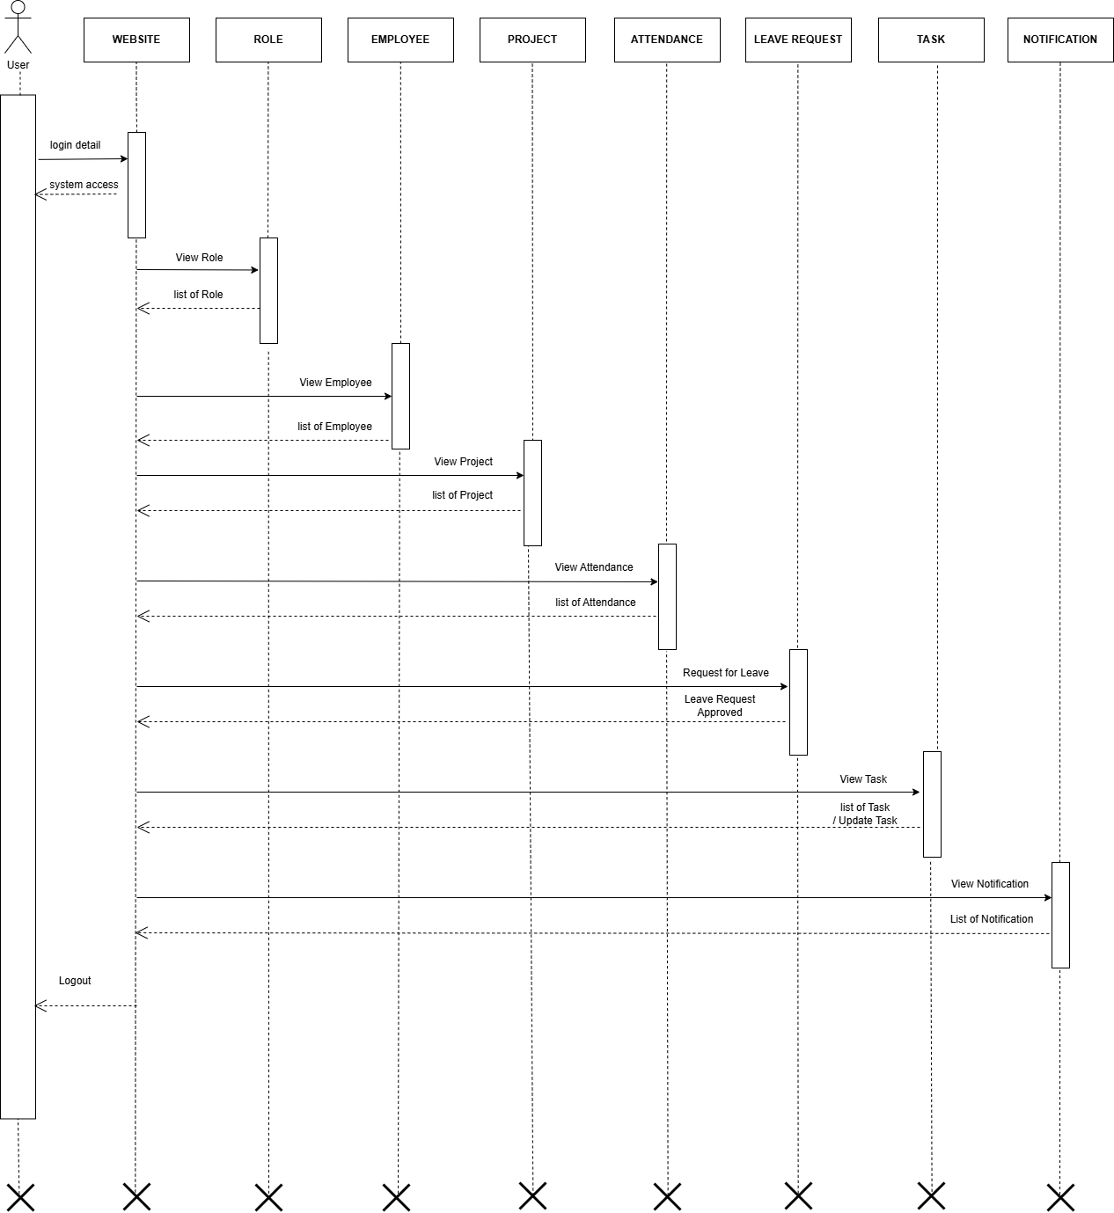

Fig 4.2.2 Sequence Diagram for User of Human Resource Management System

4.3 COLLABORATION DIAGRAM
4.3.1 COLLABORATION DIAGRAM FOR ADMIN
E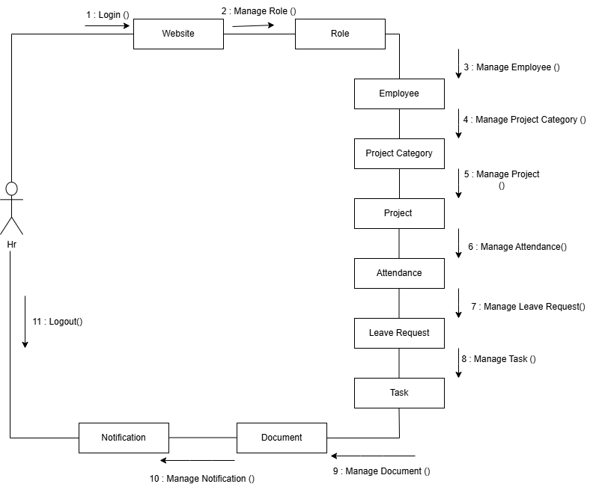

Fig 4.3.1 Collaboration Diagram for Admin of Human Resource Management System

4.3.2 COLLABORATION DIAGRAM FOR USER

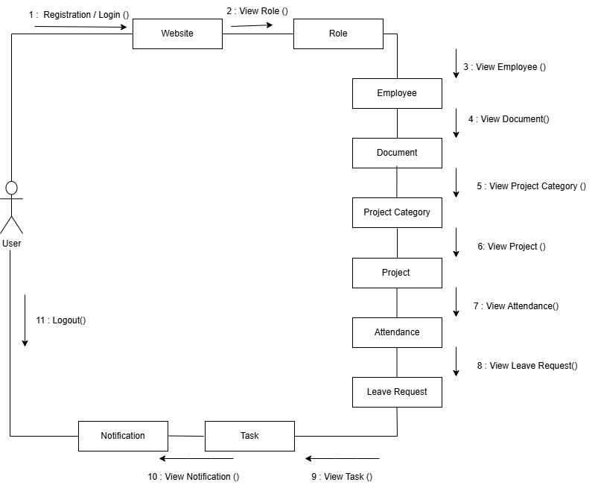

Fig 4.3.2 Collaboration Diagram for User of Human Resource Management System

4.4 STATE DIAGRAM

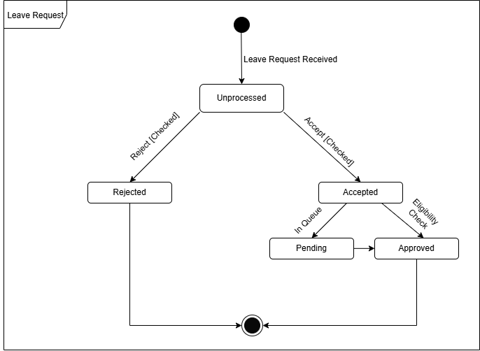

Fig 4.4 Sequence Diagram for Order of Human Resource Management System

4.5 ACTIVITY DIAGRAM
4.5.1 ACTIVITY DIAGRAM FOR ADMIN

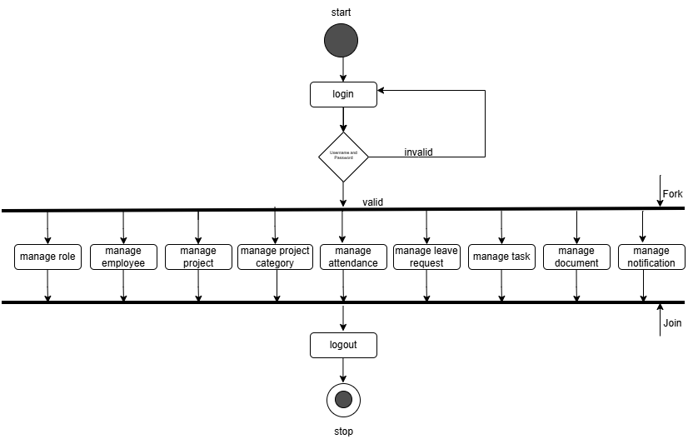

Fig 4.5.1 Activity Diagram for Admin of Human Resource Management System

4.5.2 ACTIVITY DIAGRAM FOR USER

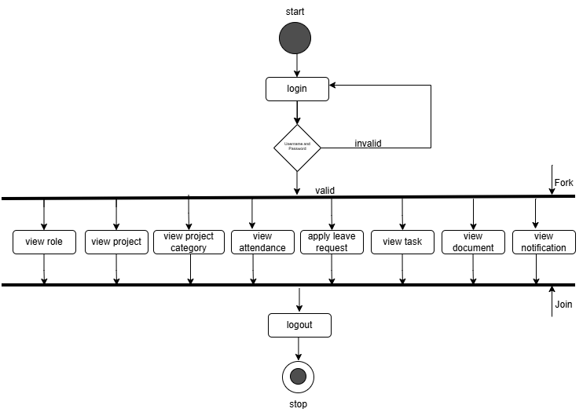

Fig 4.5.2 Activity Diagram for User of Human Resource Management System

4.6 USE CASE DIAGRAM
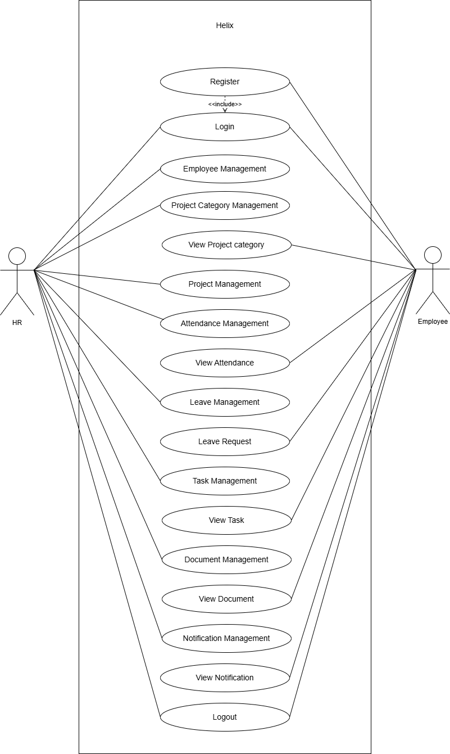

Fig 4.6 Use case Diagram of Human Resource Management System
  - DATA FLOW DIAGRAM

    - DATA FLOW DIAGRAM LEVEL 0

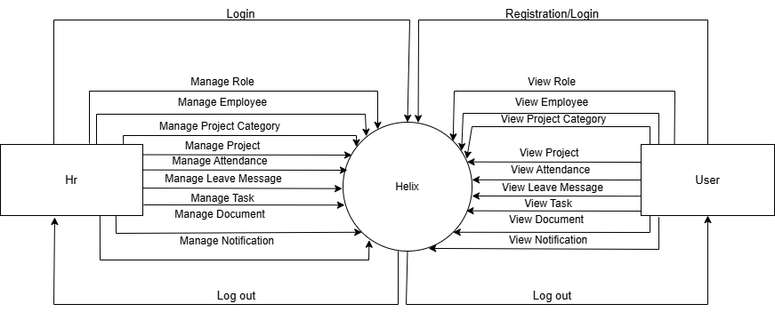

Fig 4.7.1 Data Flow Diagram Level 0 of Human Resource Management System

4.7.2 DATA FLOW DIAGRAM LEVEL 1 FOR ADMIN

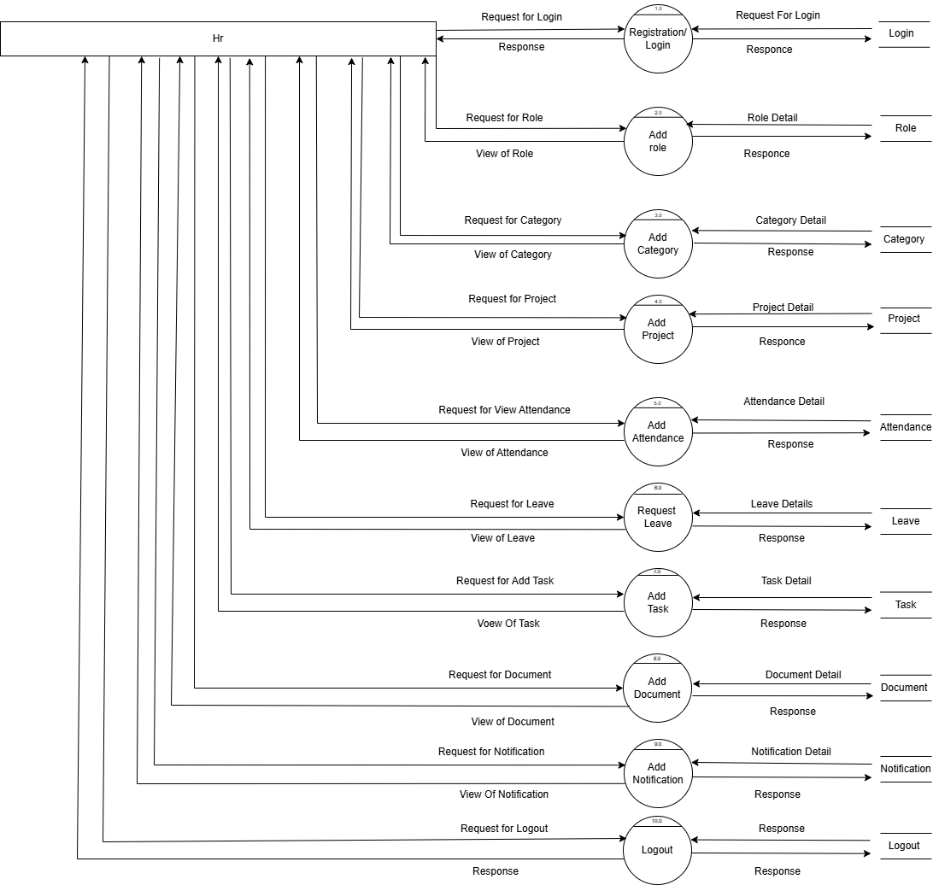

Fig 4.7.2 Data Flow Diagram for Level 1 for Admin of Human Resource Management System

4.7.3 DATA FLOW DIAGRAM LEVEL 1 FOR USER

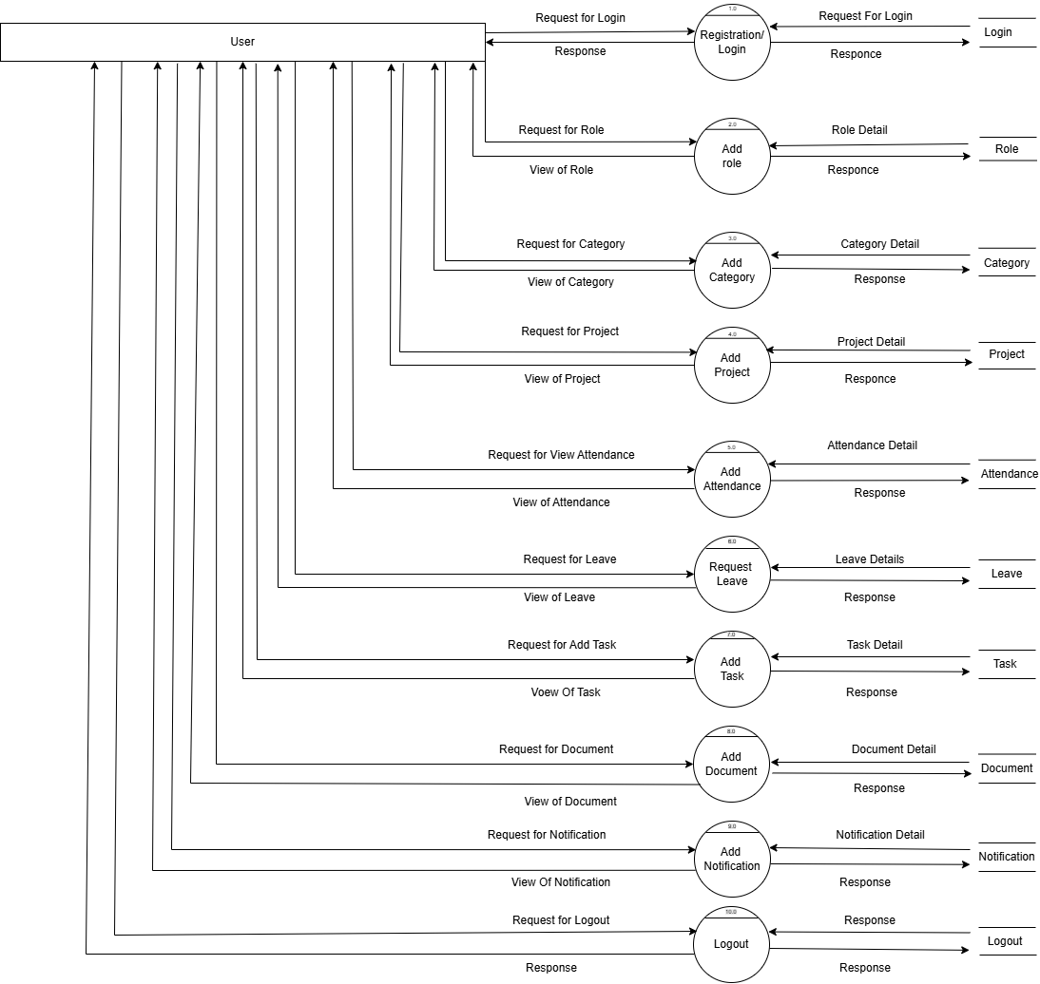

Fig 4.7.3 Data Flow Diagram for Level 1 for User of Human Resource Management System

5.DATA DICTIONARY
5.1DATABASE TABLES

Table: hr_admins

Field Name | Data Type | Size | Constraints | Reference
Hr_id | int | 11 | NOT NULL | PRIMARY KEY
Hr_code | varchar | 150 | NOT NULL | -
Hr_firstName | varchar | 100 | DEFAULT NULL | -
Hr_lastName | varchar | 100 | DEFAULT NULL | -
Hr_email | varchar | 255 | NOT NULL | UNIQUE
Hr_password | varchar | 255 | NOT NULL | -
Hr_phone | varchar | 20 | DEFAULT NULL | -
Created_at | datetime | - | DEFAULT current_timestamp() | -

Table: documents

Field Name | Data Type | Size | Constraints | Reference
Doc_id | int | 11 | NOT NULL | PRIMARY KEY
Emp_id | int | 11 | DEFAULT NULL | -
File_name | varchar | 255 | NOT NULL | -
File_type | varchar | 100 | DEFAULT NULL | -
File_path | varchar | 255 | NOT NULL | -
Uploaded_by | int | 11 | DEFAULT NULL | -
Uploaded_at | datetime | - | DEFAULT current_timestamp() | -

Table: project_assign
Field Name | Data Type | Size | Constraints | Reference
Assign_id | int | 11 | NOT NULL | -
Project_id | int | 11 | NOT NULL | PRIMARY KEY
Emp_id | int | 11 | NOT NULL | -
Assigned_at | datetime | - | DEFAULT current_timestamp() | -

Table: employees

Field Name | Data Type | Size | Constraints | Reference
Emp_id | int | 11 | NOT NULL | PRIMARY KEY
Emp_code | varchar | 50 | NOT NULL | -
Emp_firstName | varchar | 100 | NOT NULL | -
Emp_lastName | varchar | 100 | NOT NULL | -
Emp_email | varchar | 255 | NOT NULL | UNIQUE
Emp_password | varchar | 255 | NOT NULL | -
Emp_phone | varchar | 50 | DEFAULT NULL | -
Emp_dob | date | - | DEFAULT NULL | -
Emp_gender | varchar | 10 | DEFAULT NULL | -
Joining_date | date | - | DEFAULT NULL | -
ProjectCategory_id | int | 11 | DEFAULT NULL | -
Salary | decimal | - | (12 | -
Address | text | - | DEFAULT NULL | -
Profile_pic | varchar | 255 | DEFAULT NULL | -
Status | varchar | 20 | DEFAULT 'Active' | -
Created_at | datetime | - | DEFAULT current_timestamp() | -

Table: attendance
Field Name | Data Type | Size | Constraints | Reference
Attendance_id | int | 11 | NOT NULL | PRIMARY KEY
Emp_id | int | 11 | NOT NULL | FOREIGN KEY
Date | date | - | NOT NULL | -
Status | varchar | 20 | NOT NULL | -
Checkin_time | time | - | DEFAULT NULL | -
Checkout_time | time | - | DEFAULT NULL | -
Marked_by | int | 11 | DEFAULT NULL | -
Table: leaves

Field Name | Data Type | Size | Constraints | Reference
Leave_id | int | 11 | NOT NULL | PRIMARY KEY
Emp_id | int | 11 | NOT NULL | FOREIGN KEY
Leave_type | varchar | 100 | DEFAULT NULL | -
Start_date | date | - | DEFAULT NULL | -
End_date | date | - | DEFAULT NULL | -
Days | int | 11 | DEFAULT NULL | -
Status | varchar | 20 | DEFAULT 'Pending' | -
Comment | text | - | DEFAULT NULL | -
Attachment | varchar | 255 | DEFAULT NULL | -
Requested_at | datetime | - | DEFAULT current_timestamp() | -
Action_by | int | 11 | DEFAULT NULL | -

Table: tasks

Field Name | Data Type | Size | Constraints | Reference
Task_id | int | 11 | NOT NULL | PRIMARY KEY
Title | varchar | 255 | NOT NULL | -
Description | text | - | DEFAULT NULL | -
Assigned_by | int | 11 | DEFAULT NULL | FOREIGN KEY
Assigned_to | int | 11 | DEFAULT NULL | FOREIGN KEY
Priority | varchar | 50 | DEFAULT NULL | -
Status | varchar | 50 | DEFAULT 'Pending' | -
Due_date | date | - | DEFAULT NULL | -
Created_at | datetime | - | DEFAULT current_timestamp() | -

Table: notifications

Field Name | Data Type | Size | Constraints | Reference
Notification_id | int | 11 | NOT NULL | PRIMARY KEY
Target_type | varchar | 20 | NOT NULL | -
Target_id | int | 11 | NOT NULL | -
Title | varchar | 255 | NOT NULL | -
Message | text | - | DEFAULT NULL | -
Status | varchar | 20 | DEFAULT 'Unread' | -
Created_at | datetime | - | DEFAULT current_timestamp() | -

Table: projects

Field Name | Data Type | Size | Constraints | Reference
Project_id | int | 11 | NOT NULL | PRIMARY KEY
Project_name | varchar | 200 | NOT NULL | -
ProjectCategory_id | int | 11 | DEFAULT NULL | -
Description | text | - | DEFAULT NULL | -
Start_date | date | - | DEFAULT NULL | -
End_date | date | - | DEFAULT NULL | -
Status | varchar | 50 | DEFAULT 'Active' | -
Created_at | datetime | - | DEFAULT current_timestamp() | -

Table: project_category
Field Name | Data Type | Size | Constraints | Reference
ProjectCategory_id | int | 11 | NOT NULL | PRIMARY KEY
Category_name | varchar | 150 | NOT NULL | -
Description | text | - | DEFAULT NULL | -
Created_at | datetime | - | DEFAULT current_timestamp() | -

5.1ER-DIAGRAM
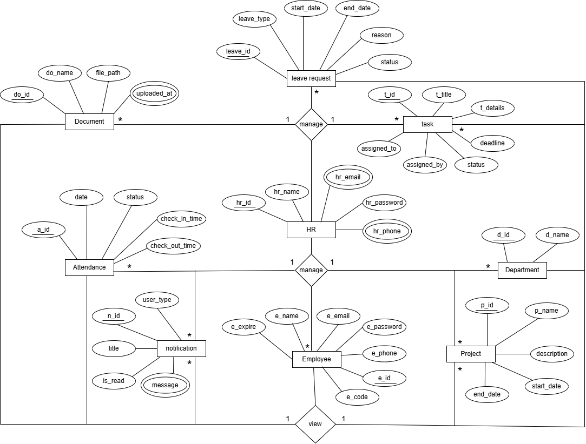

Fig 5.1 ER Diagram of Human Resource Management System

Fig 6.2 Shop Page

  - This Shop page showcases bag products with price details.
  - Users can quickly add items to their cart for easy shopping.

ABOUT US PAGE

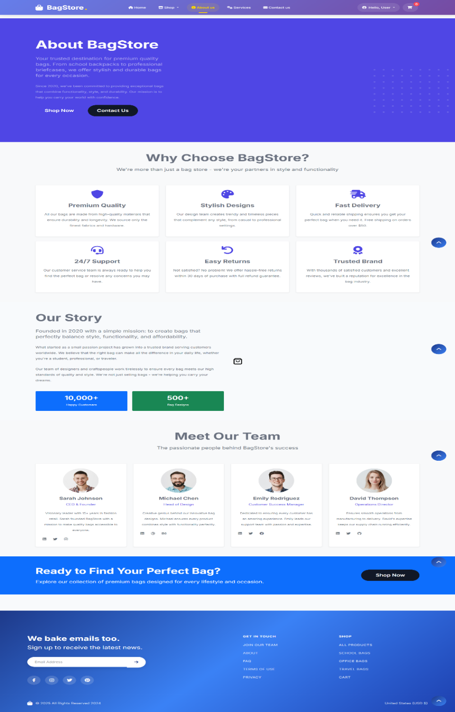

Fig 6.3 About us Page

- This page presents BagStore’s mission and story with a focus on quality and stylish bags.
- It also introduces the team and highlights customer trust and achievements.

SERVICES PAGE

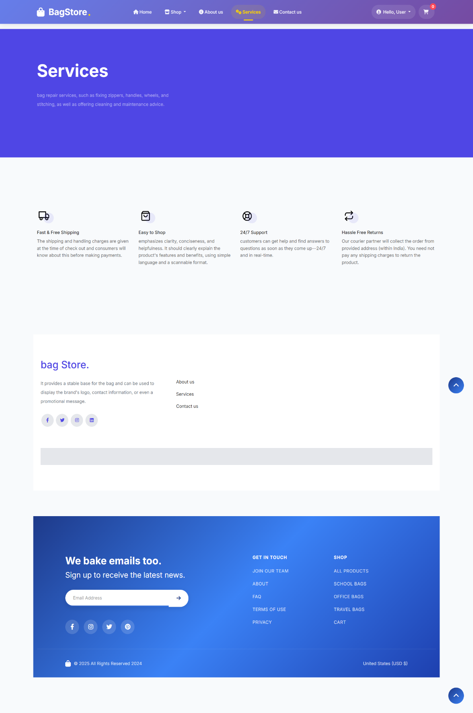
Fig 6.4 Services Page

- This Services page highlights bag repair, cleaning, and maintenance support.
- It also assures fast shipping, 24/7 support, easy shopping, and hassle-free returns.

CONTACT US PAGE

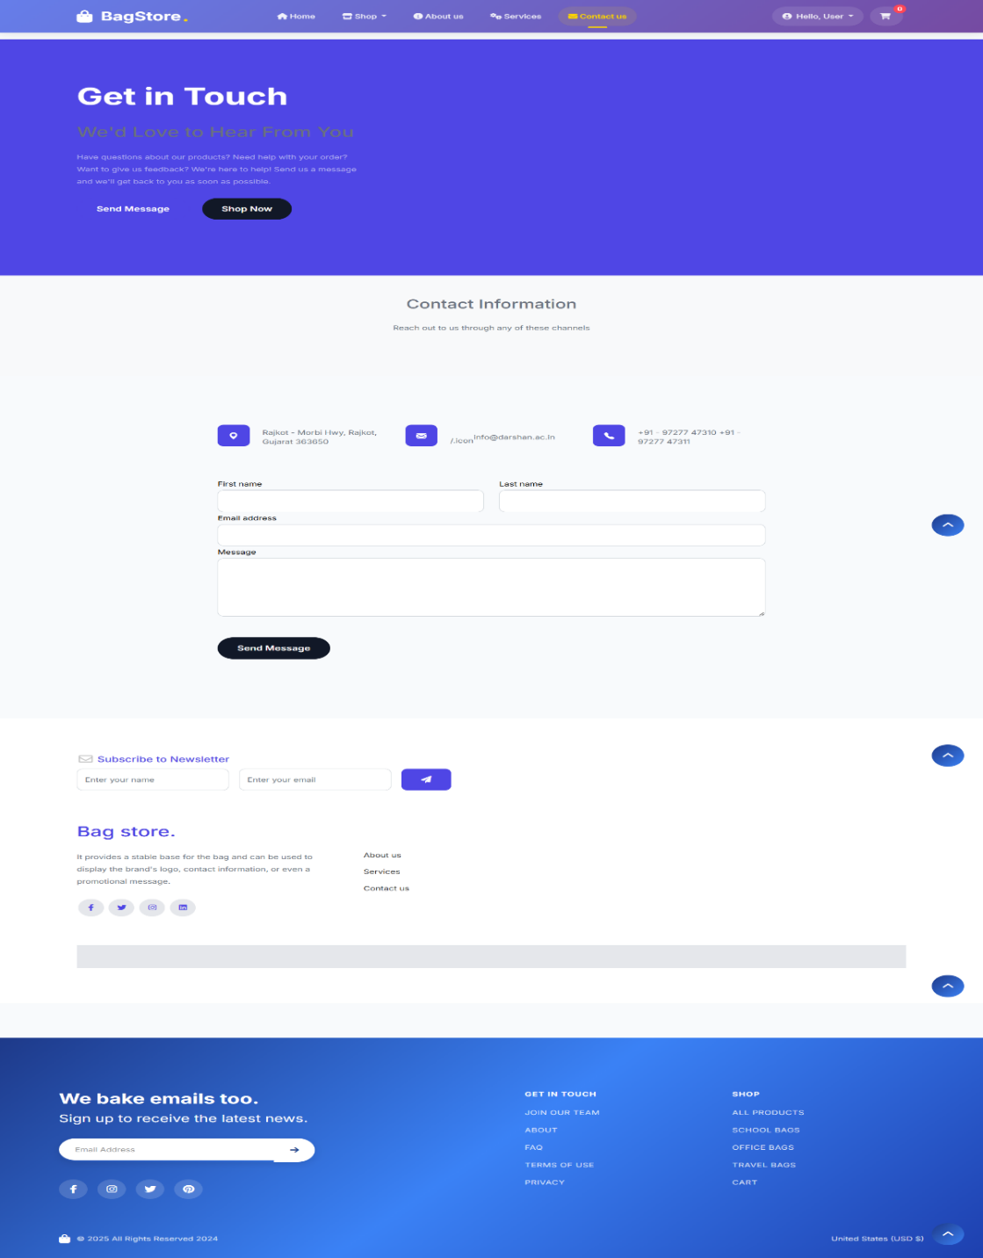

Fig 6.5 Contact us Page

- This Contact Us page allows users to reach BagStore through a form, email, phone, or address.
- It makes communication easy for queries, feedback, or support.

CART PAGE

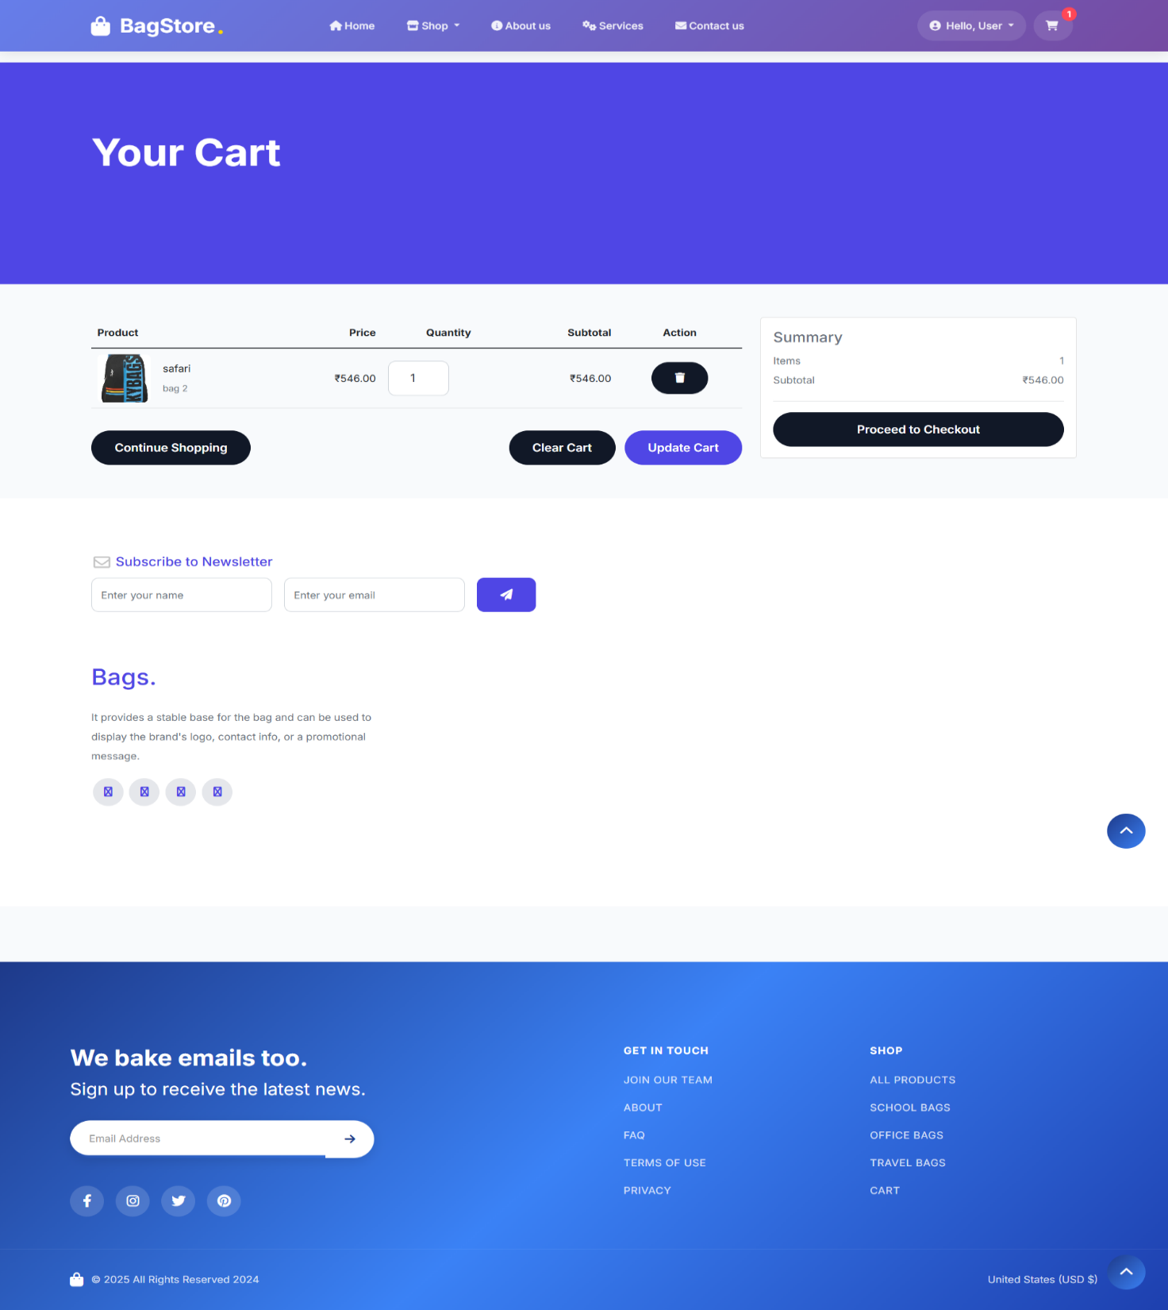
Fig 6.6 Cart Page

- Users can quickly add items to their cart for easy shopping.
- It allows users to update, clear the cart, or proceed to checkout easily.

CHECKOUT PAGE

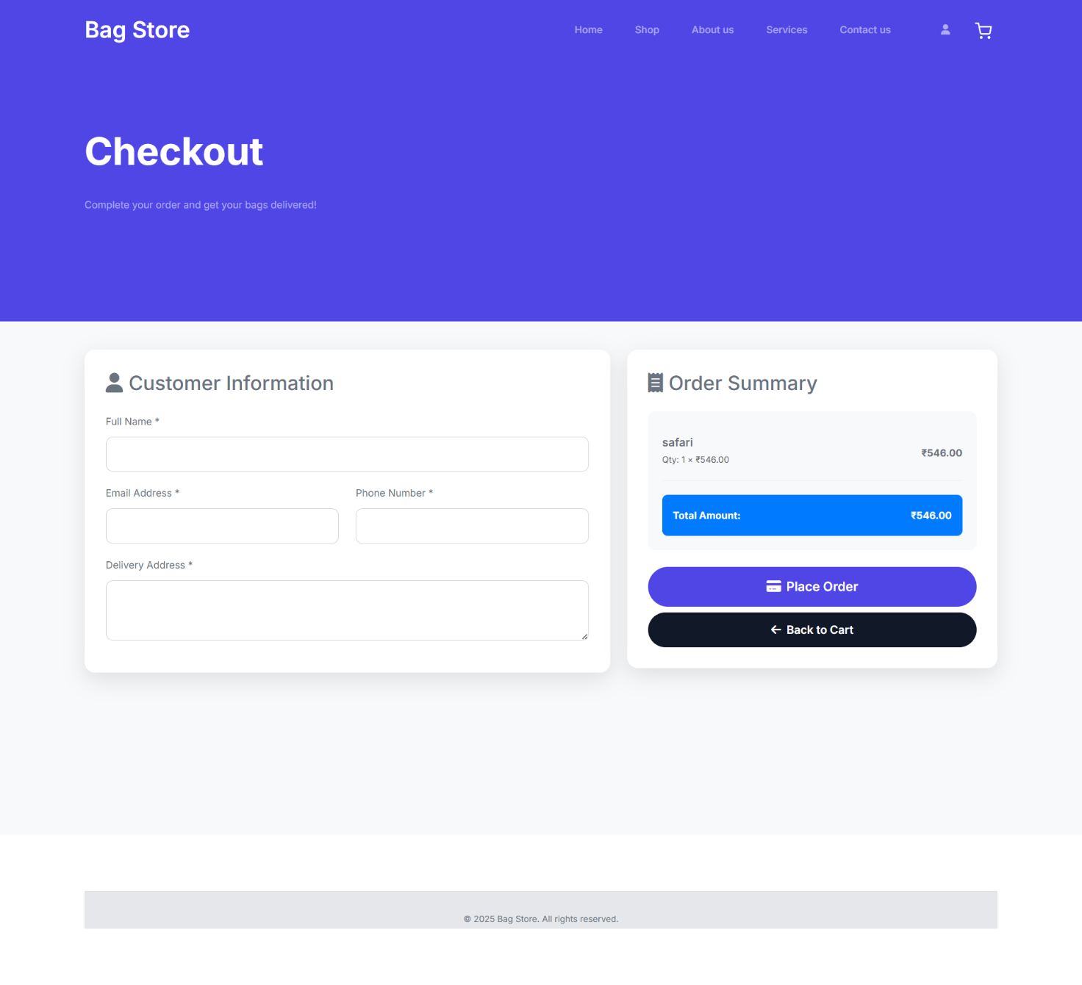
Fig 6.7 Checkout Page

- Complete your order in just a few steps.
- Fast delivery, secure payment, hassle-free shopping.

THANKYOU PAGE

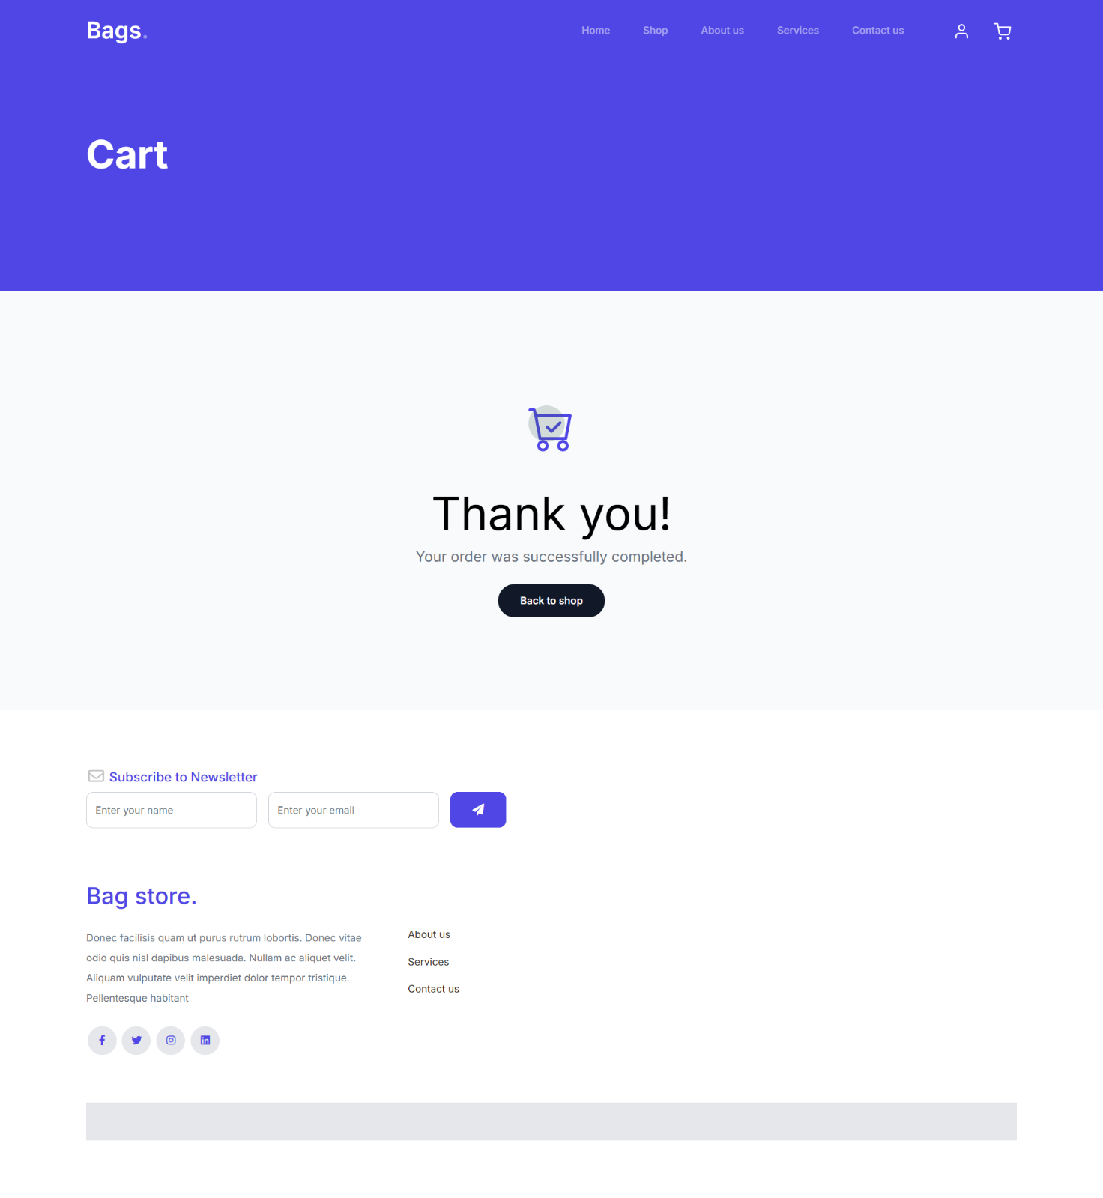
Fig 6.8 Thankyou Page

- Your order is confirmed and on its way.
- Thank you for shopping with us – we can’t wait to serve you again.

ADMIN PANEL

ADMIN DASHBOARD
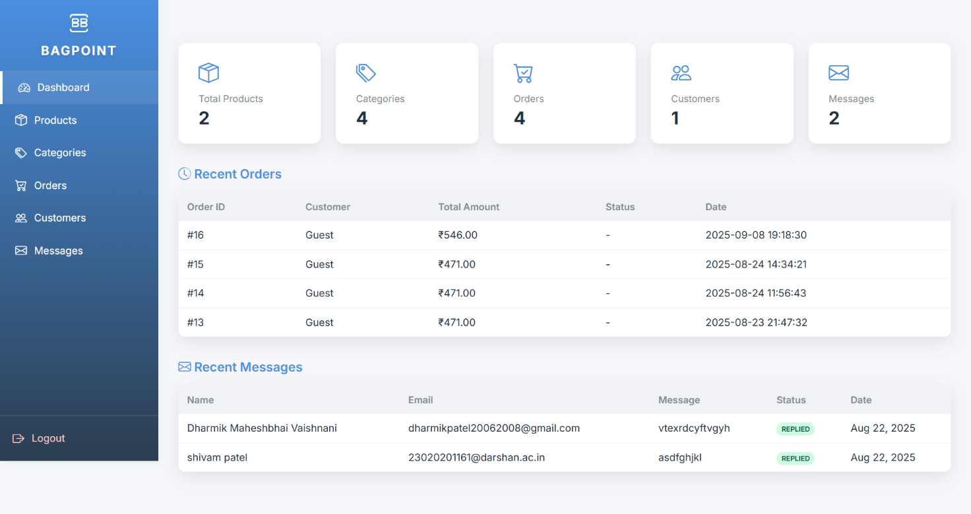
Fig 6.9 Admin Dashboard Page

- Manage products, orders, and customers in one place.
- Stay updated with recent activity and messages instantly.

PRODUCT PAGE

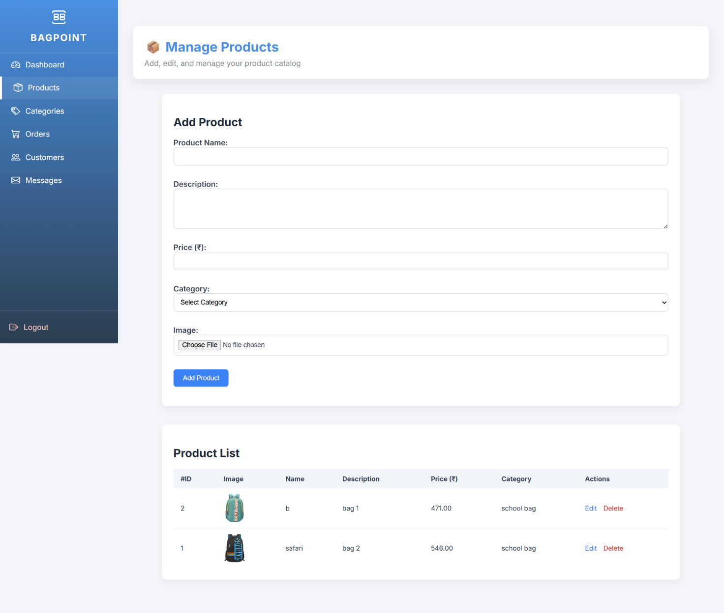

Fig 6.10 Manage Product Page

- Easily add, edit, and organize your products.
- Keep your catalog up-to-date with just a click.

CATEGORY PAGE

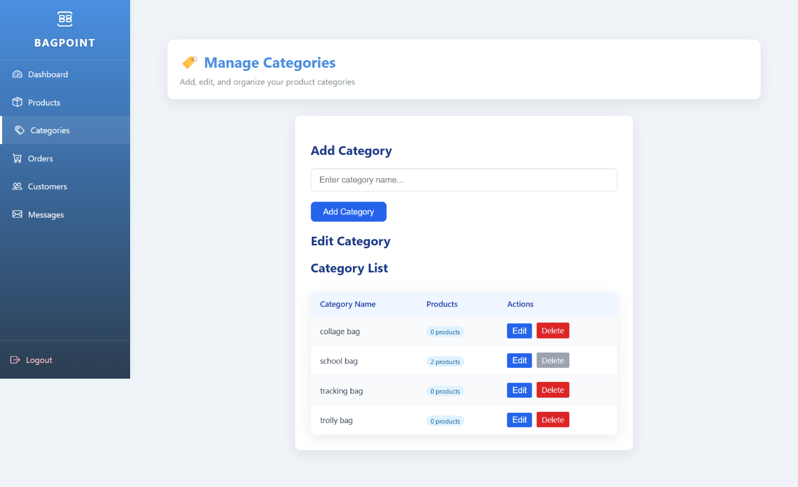

Fig 6.11 Category Page

- Create and organize product categories with ease.
- Keep your store structured for a smooth shopping experience.

ORDERS PAGE

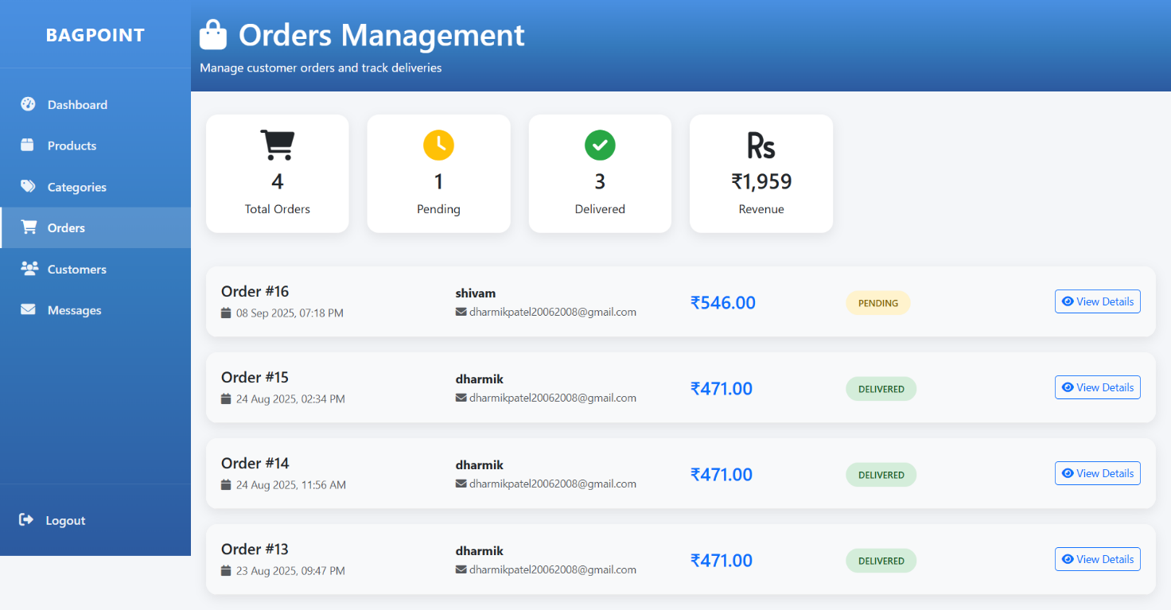

Fig 6.12 Orders Page

- Track, manage, and update all customer orders in real-time.
- Stay on top of pending and delivered orders with ease

CUSTOMER PAGE

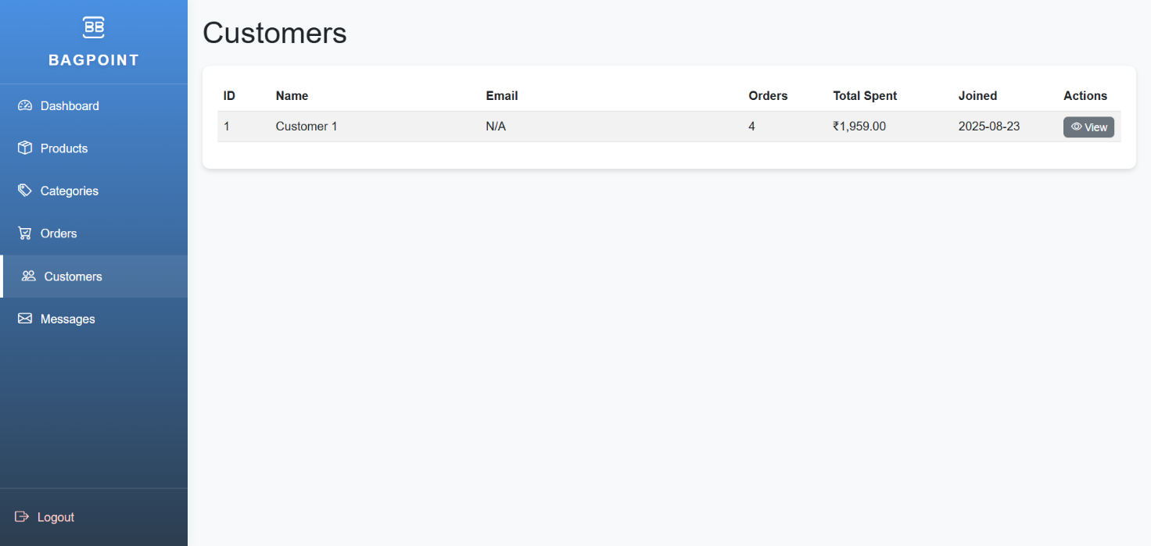

Fig 6.13 Customer Page

- Customer details with orders and spending summary.
- Manage and track customer activity.

MESSAGE PAGE

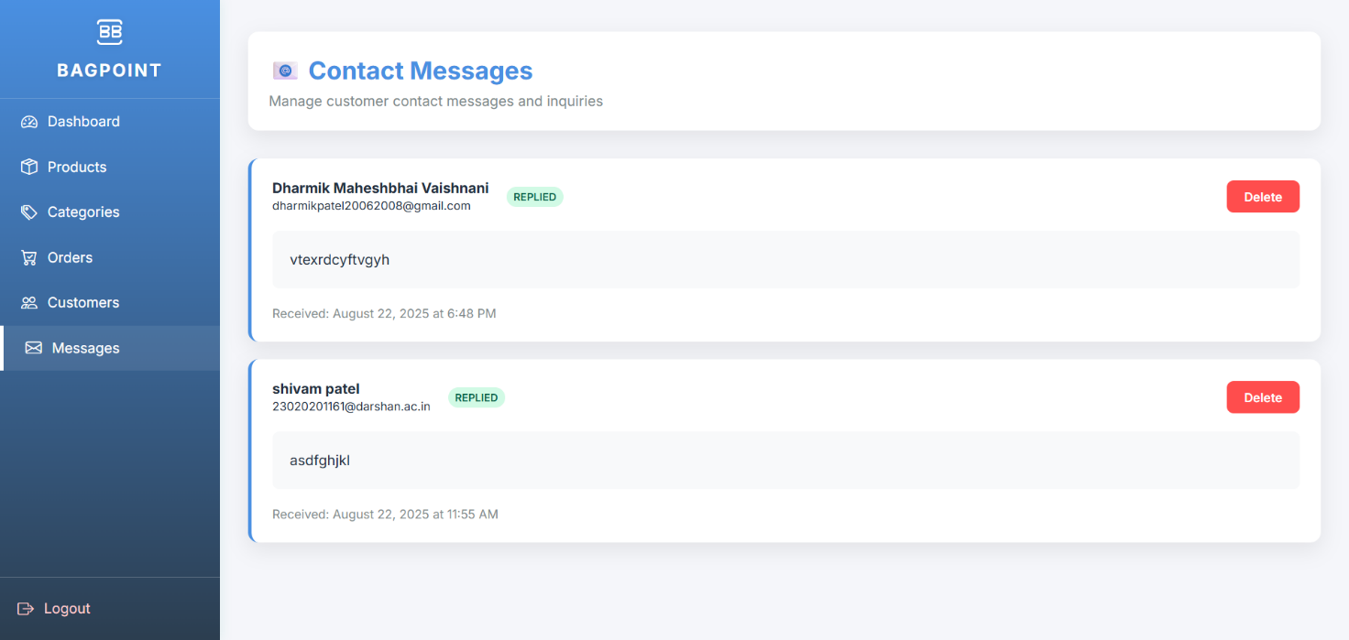
Fig 6.14 Message Page

- This page displays customer contact messages and replies.
- Admins can view or delete inquiries easily.

7.CONCLUSION

The HRMS website helps companies manage their employees more easily by automating tasks like payroll, recruitment, performance reviews, and leave requests. It reduces paperwork, saves time, and avoids mistakes in employee data. With a simple and secure interface, employees and HR teams can communicate better and access information quickly. The website acts as a one-stop platform for all employee-related details, making updates and tracking easier. Overall, the HRMS website improves efficiency, promotes transparency, and helps organizations make better decisions, leading to smoother operations and business growth.

8.FUTURE ENHANCMENT

In the future, the HRMS website can be improved by using Artificial Intelligence (AI) to automate tasks and predict employee needs. Adding chatbox will help employees get instant answers to their queries. A mobile app can make it easier for employees to access HR services from anywhere. Features like biometric attendance and cloud storage will increase security and data accessibility. Advanced performance tracking and automatic payroll generation will make the system more efficient, helping organizations manage their workforce better and improve overall productivity.

9.REFERENCES

Description | Websites
Bootstrap 5 | https://themewagon.com/themes/furni-online-store/

